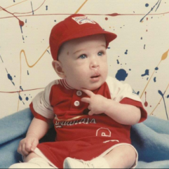 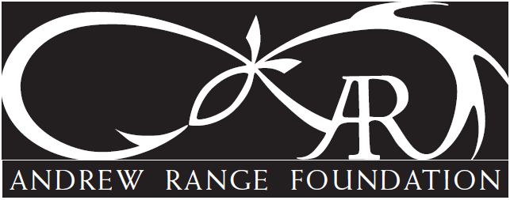 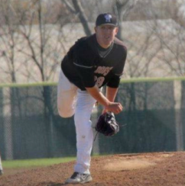

On Saturday, June 7, 2025 the 7th Andrew Range Memorial Golf Tournament will be held at Fox Creek Golf Course in Edwardsville!!!

In preparation for this year’s event, **we ask that you become one of our generous sponsors by donating either a $250 Hole Sponsorship or donate an item for the silent auction by filling out and returning the attached sheet.**

Andrew, a Triad High School graduate was in his first year of law school at Southern Illinois-Carbondale when he tragically passed away in December, 2017. The thriving Andrew Range Golf Memorial Fund was established to give to the Andrew Range Foundation – a 501c3 organization established to pay forward Andrew’s positive influence.

As in all preceding years, the Andrew Range Memorial Golf Tournament, Dinner and Silent Auction has been a sold-out event of over 250 individuals. Due to the generosity over the past 6 years with over 300 sponsorships, the tournament has helped to raise over $95,000 for the Andrew Range Foundation.

Since the inception of the foundation in 2018, we have been able do some amazing things on behalf of Andrew. Specifically:

* **The past 5 years have issued a Premier-level ($10,000 each year) donation to Smile Train, the world leading cleft charity.** These donation amounts enable lifesaving support including ~25 cleft surgeries and support care including social workers, speech therapist, dentists and more to children in need around the world. *
* **Awarded 15 $1000 scholarships to Triad High School players. \***
* **Fully met Endowment Level Scholarship in 2018 at Truman State University and awarded annual scholarships. \***
* **Fully met Endowment Level Scholarship in 2018 at Southern Illinois University at Carbondale Law and awarded annual scholarships. \***
* **The past 2 years issued Gold (top) Sponsorship of Laps for Leaps**: Leaps of Love – Charity organization supporting families affected by brain tumors and late childhood cancers.
* **And much, more!**

* *Annotates Annual Foundation Commitment*

For more information, please see https://www.andrewrangefoundation.com/golf-tournament or call Dawn Schmidt at 618-795-4502.

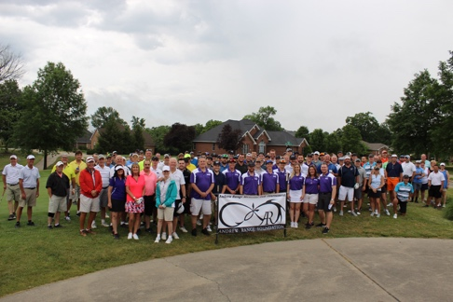

**ANDREW RANGE MEMORIAL FOUNDATION**

**SEVENTH ANNUAL GOLF TOURNAMENT (June 7, 2025)**

COMPANY NAME: ___________________________________________________

CONTACT PERSON: __________________________________________________

PHONE NUMBER: ___________________________________________________

YES, I would like to contribute:

____________ $250 Hole Sponsorship (will include company name/logo)

____________ Silent Auction Item (request by 6/1/25)

Please Specify: ___________________________________________

Approximate Value: _______________________________________

Please make check for hole sponsorship to:

**Andrew Range Memorial Golf**

Mail checks and/or auction items to: Dawn Schmidt

4772 Drda Ln

Edwardsville, IL 62025

We can also pick up any silent auction items.

**THANK YOU SO MUCH FOR HELPING TO MAKE THIS MEMORY OF ANDREW A SUCCESS!!!**

**The Andrew Range Memorial Fund (Registration ID is 82-3955195) is federally registered/approved (501c3)**